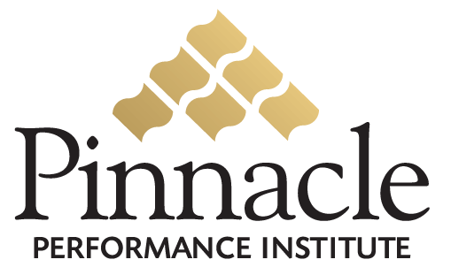

Pinnacle Presentation

Outline
- Unique Selling Proposition
  - Performance Enhancement Solution
- Enhance Desire with Key Benefits
  - M – Measure Strengths and Weaknesses
  - B – Build Confidence and Competence
  - E – Enable Effective Communication
- Create Rationale with Features
  - M – Measure Strengths and Weaknesses
  - B – Build Confidence and Competence
  - E – Enable Effective Communication
- Pinnacle Performance Institute … Can Do For You
  - Free Enterprise Training Buffet
  - Microsoft Senior Technologist Founder
  - Internet Business Expertise
- Build Trust and Credibility with Reviews and Testimonials
  - EcoQuest, Jack Wilder
  - IBI, Kenda-Le Pernin
  - DHL, Gary Taylor
- Eliminate Risk with Guarantees and Return Policies
  - No Upfront Costs
  - No Long-term Contracts
- Make a Compelling Irresistible Offer
  - Very Affordable Solution
  - Personal Assistant (Account Executive)
  - Deployment Resources
- Close with your solid “Most Wanted Response”
  - Deployment Plan
    - Identify Target Groups
    - Identify Training Content
    - Identify Schedule
    - Identify Key Players
    - Identify Promotion Plan
- Be prepared with a Backup Response?
  - Trial Membership
- Tell the Prospect exactly what you want them to do
  - Champion the Project
  - Execute the Deployment Plan

